# **SSH Troubleshooting**

**1) There's a connection timeout**

This is a security group issue. Any timeout (not just for SSH) is related to security groups or a firewall. Ensure your security group looks like this and correctly assigned to your EC2 instance.

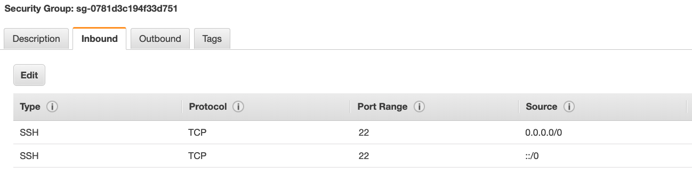

**2) There's still a connection timeout issue**

If your security group is properly configured as above, and you still have connection timeout issues, then that means a corporate firewall or a personal firewall is blocking the connection. **Please use EC2 Instance Connect as described in the next lecture.**

**3) SSH does not work on Windows**

* If it says: ssh command not found, that means you have to use Putty
* Follow again the video. If things don't work, please use EC2 Instance Connect as described in the next lecture

**4) There's a connection refused**

This means the instance is reachable, but no SSH utility is running on the instance

* Try to restart the instance
* If it doesn't work, terminate the instance and create a new one. Make sure you're using **Amazon Linux 2**

**5)  Permission denied (publickey,gssapi-keyex,gssapi-with-mic)**

This means either two things:

* You are using the wrong security key or not using a security key. Please look at your EC2 instance configuration to make sure you have assigned the correct key to it.
* You are using the wrong user. Make sure you have started an **Amazon Linux 2 EC2 instance**, and make sure you're using the user **ec2-user.**This is something you specify when doing **ec2-user@**<public-ip> (ex: ec2-user@35.180.242.162) in your SSH command or your Putty configuration

**6) Nothing is working - "aaaahhhhhh"**

Don't panic. Use **EC2 Instance Connect** from the next lecture. Make sure you started an **Amazon Linux 2** and you will be able to follow along with the tutorial :)

**7) I was able to connect yesterday, but today I can't**

This is probably because you have stopped your EC2 instance and then started it again today. **When you do so, the public IP of your EC2 instance will change.** Therefore, in your command, or Putty configuration, please make sure to edit and save the new public IP.